**Computer Networks**

**Problem-solving session 5: Network Binary Math**

**1. Network Binary Math**

1.1. What are the MAC address and the vendor / manufacturer of your network adapter?

MAC address: ___F4-D1-08-54-00-DE____________

Vendor / manufacturer: 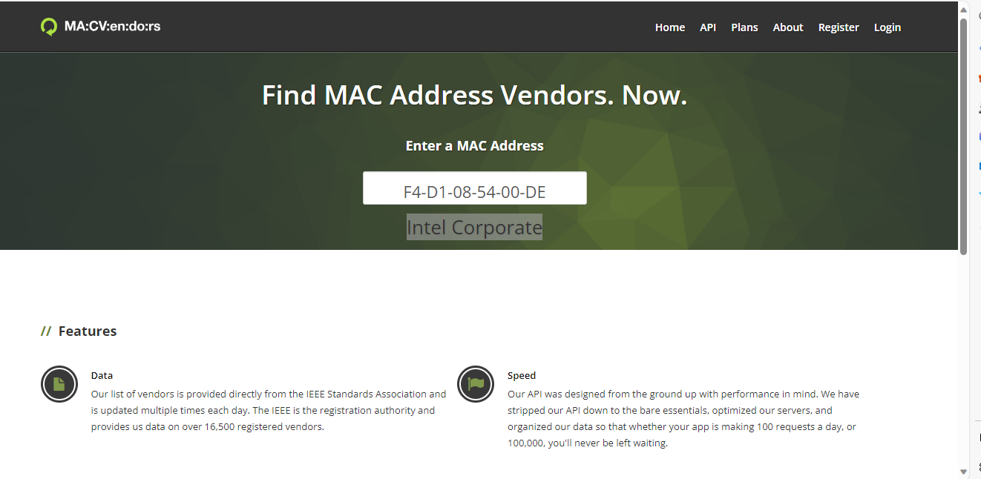

1.2. Find the IP address and the subnet mask of your network device.

IPv4 Address. . . . . . . . . . . : 10.139.33.100(Preferred)

Subnet Mask . . . . . . . . . . . : 255.255.192.0

1.3. What is the dot binary representation of the IP address and the subnet mask of your network device?

IP address (dot binary representation): 00001010.10001011.00100001.01100100.

Subnet mask (dot binary representation): 11111111.11111111.11000000.00000000.

1.4. What are the network address and the broadcast address of your network?

Network address: _10.139.0.0______________

Broadcast address: ___10.139.63.255____________

1.5. What is the range of usable host IP addresses for your network?

Range of usable host IP addresses: 10.139.0.1 - 10.139.63.254

**2. Cisco Binary Game**

**Note**: Cisco Binary Game is the Moodle assignment. In-class work will be different.

Cisco Binary Game is a way to learn binary numbers for networking.

Game link: https://learningnetwork.cisco.com/s/binary-game

Perhaps you will need to log in to cisco.com to use this link (it will be necessary to create an account if you do not already have one).

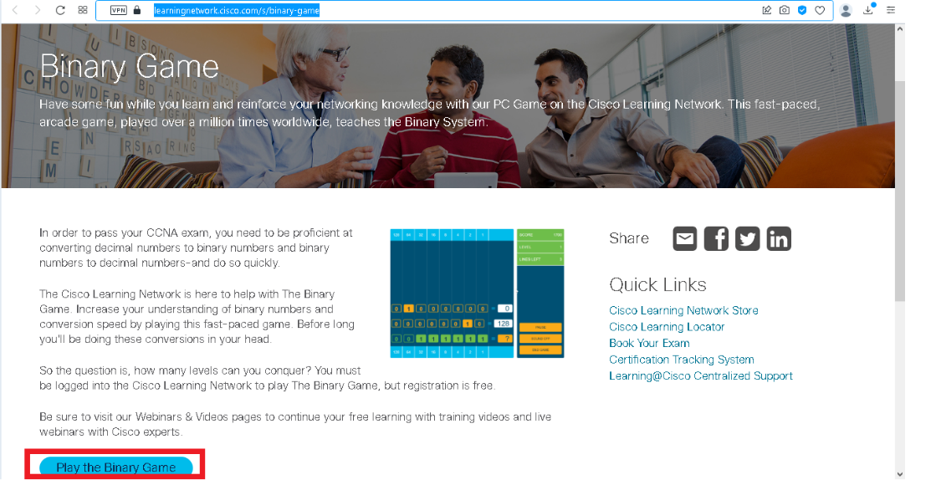

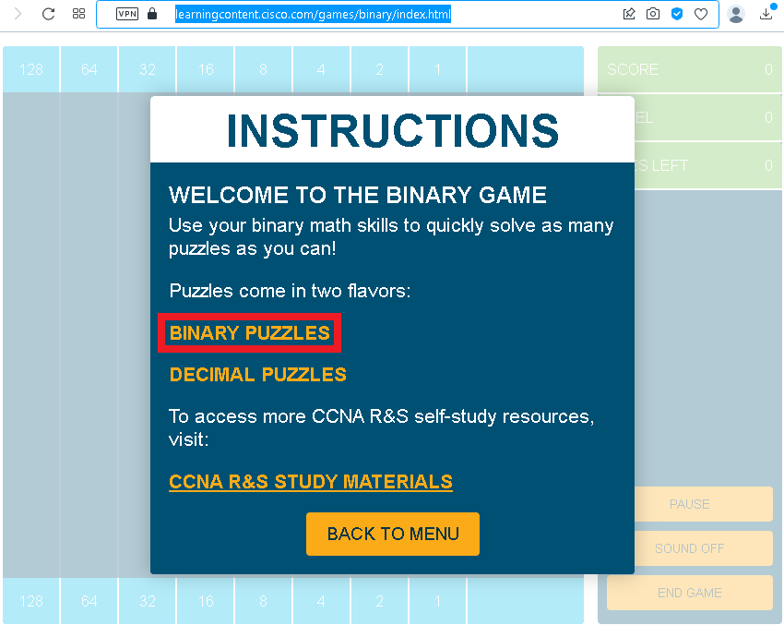 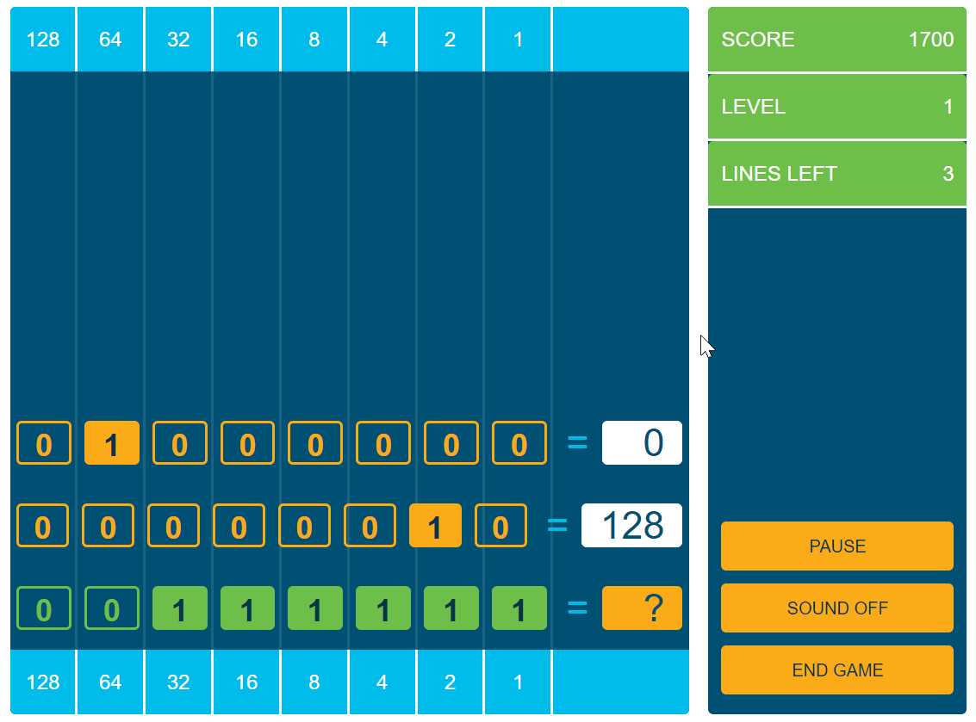

**Please show your skills in binary numbers till the 4th level when guide numbers are deactivated (upload screenshot into Moodle):**

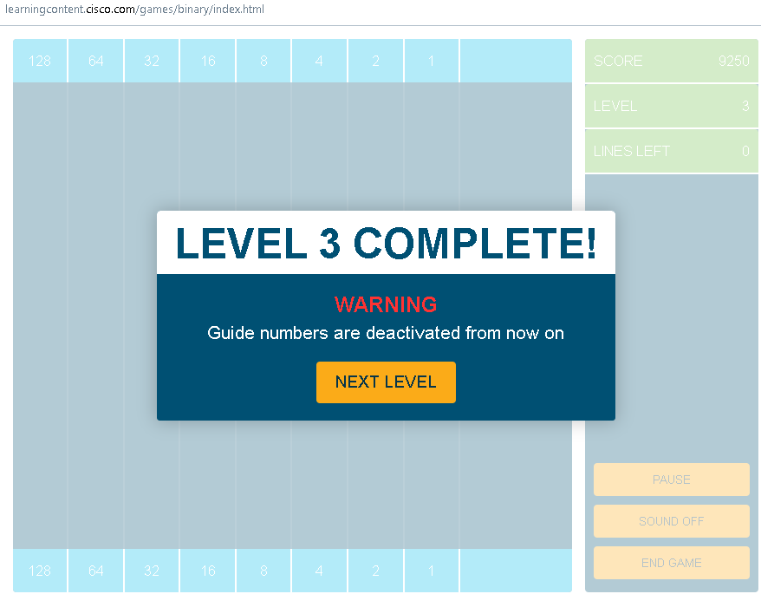

Here is the link to the video : <https://drive.google.com/file/d/1j7GKL7sgY8i4oJp14pm1uR2EH6iT6_Xa/view?usp=sharing>